NATIONAL UNIVERSITY OF MODERN LANGUAGE ISLAMABAD
Assignment 02


Submitted to:
Sir Hassan Shah
Submitted by:
Zulqarnain Hassan
Roll No: …………………… SP21379
Subject: …………………… computer network
Department: ……………… BSSE-5-Afternoon
Date: ……………………… 17-11-2024

Question 1
In Figure 9.10, show the process of frame change in routers R1 and R2.

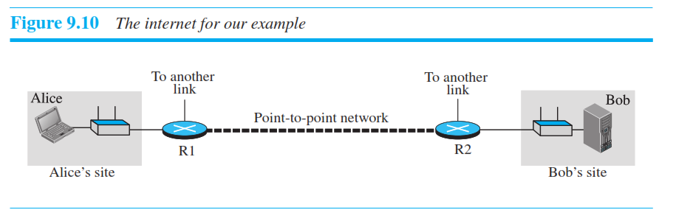
Sender Alice:
At networt layer a data packet is created with sender IP address and Bob’s destination IP address.
At data link layer a frame is created with source Alice device’s MAC address and destination R1 MAC address.
Router R1:
Data link layer at router R1 receive the frame and remove the header and create new one with source R1’s MAC address and destination MAC address of R2.
Router R2;
Data link layer at router R2 receive the frame form source R1 and remove the header and create new one with source R2’s MAC address and destination MAC address of Bob’s device.
Bob’s device:
Bob’s device receive the frame at data link layer and remove the header and processes the IP packet at the network layer.
Question 2.
Assume Ali is travelling from 67, Main Street 3, E-11/4 in Islamabad to 1432, street 65, DHA Phase II in Karachi. He wants to travel by air from Islamabad to Karachi Airport.
BUT unfortunately, Ali cannot find a direct flight from the Islamabad to the Karachi.
If he needs to change flights in Lahore.

- Find the end-to-end addresses in this scenario.

The end-to-end address will remain constant. Source address will be “67, Main Street 3, E-11/4 Islamabad” and the destination address will be “1432, street 65, DHA Phase II in Karachi”
- Find the link-layer addresses in this scenario.
Link layer address will be:
1. Ali home address “67, Main Street 3, E-11/4 Islamabad” to Islamabad airport.
2. Islamabad airport to Lahore airport.
3. Lahore airport to Karachi airport.
4. Karachi airport to the destination address “1432, street 65, DHA Phase II in Karachi”
Question 3.
Encode the data using Block coding technique of CRC, for transmission.
- Check the data for any errors at the receiver side.
Data= x⁹+x⁷+x⁶+x⁵+x³+x+1
Div = x⁴+x³+x²
^{transmitted codeword}
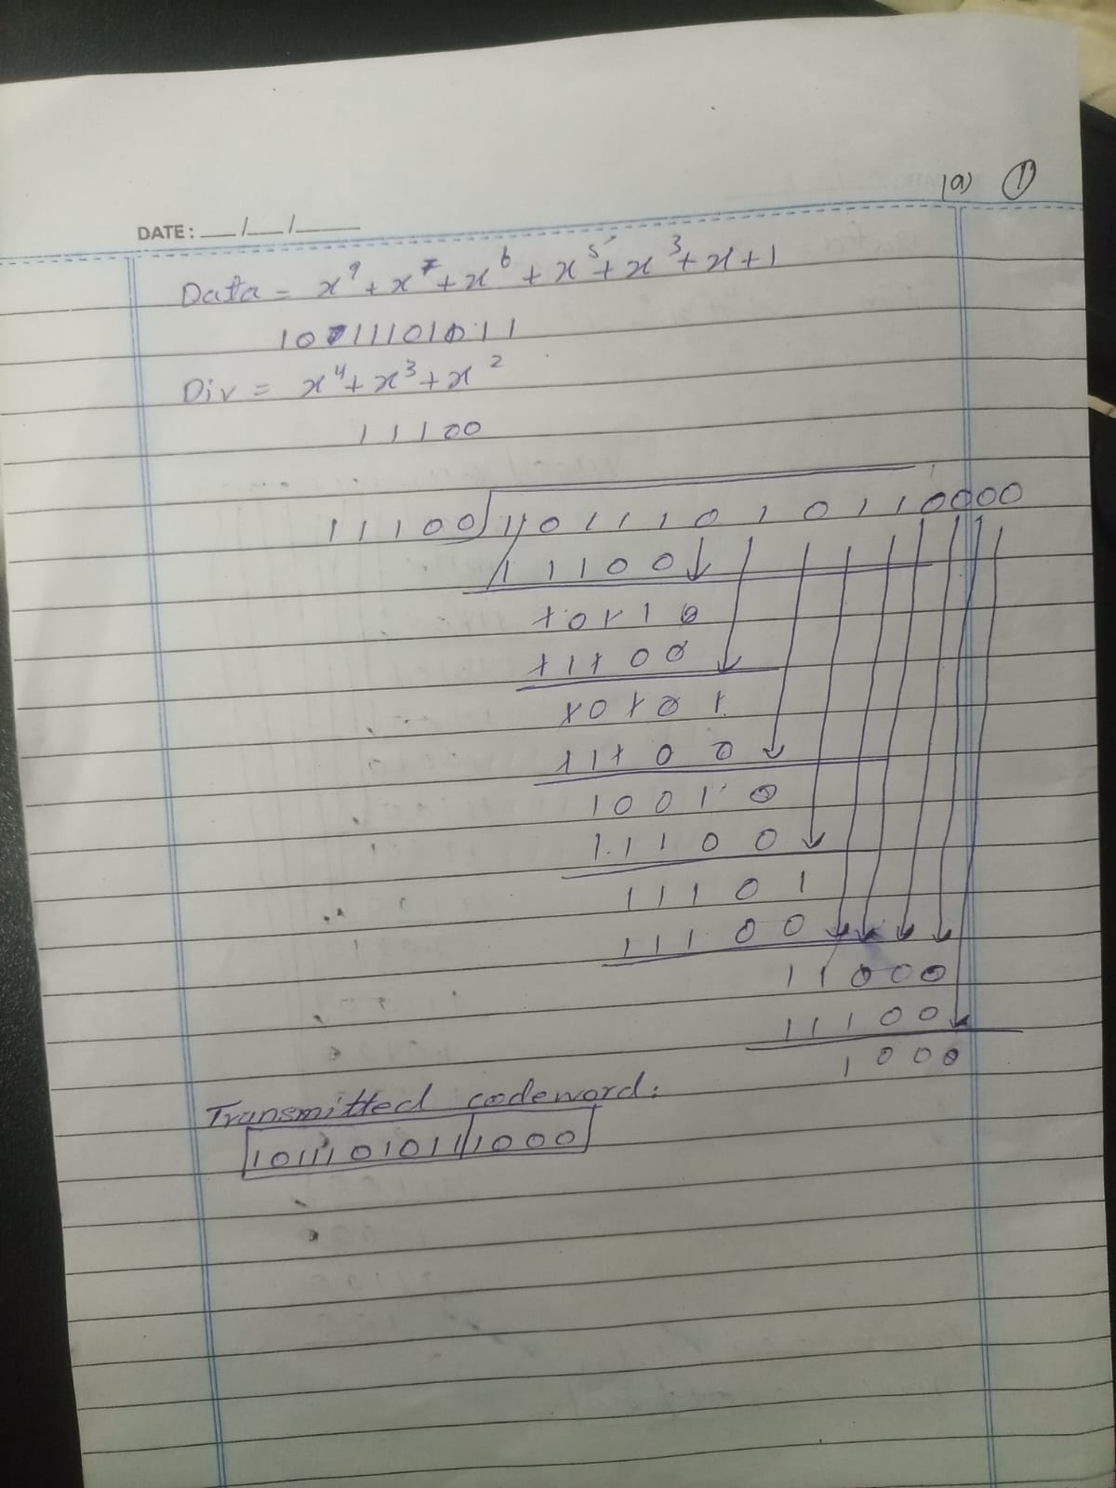

^{checking for error}
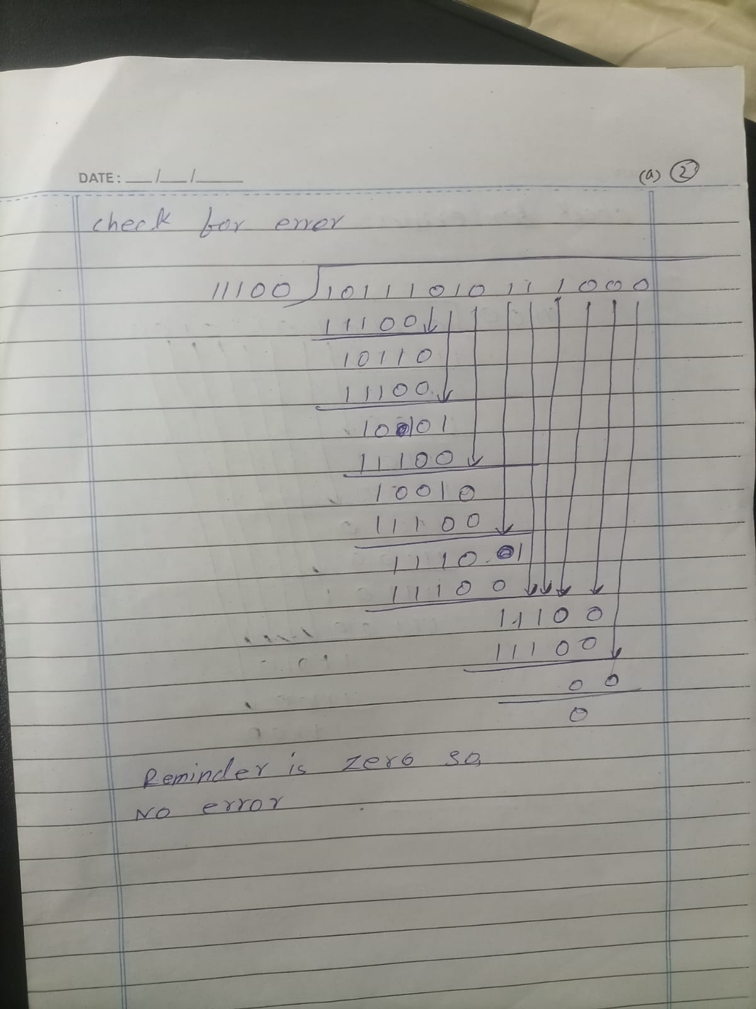

- Make an error in the 6th bit from MSB and again check for the errors.
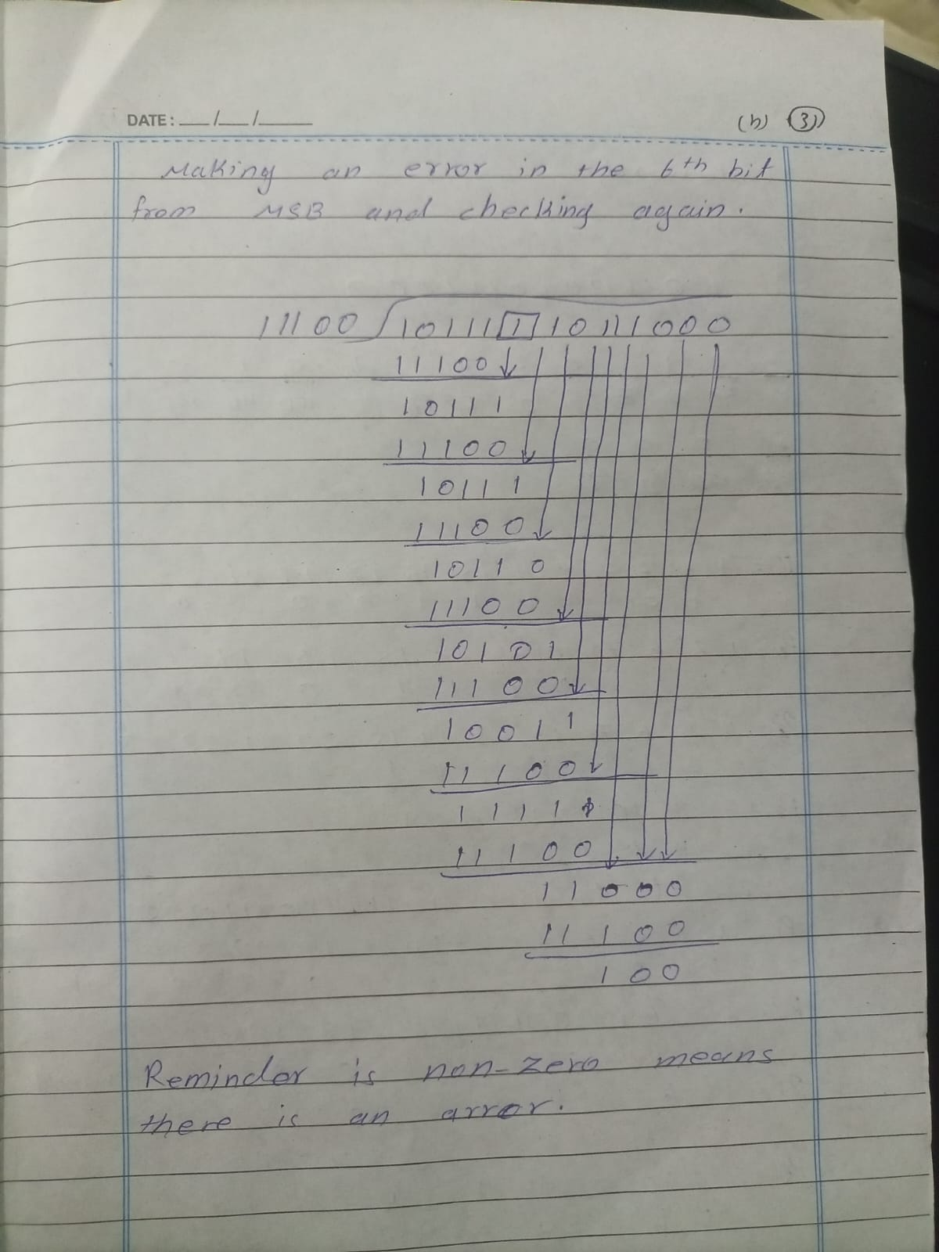

- Consider the codeword about with error as an input for hamming.
Show how Hamming corrects the erroneous bit as entered above.
